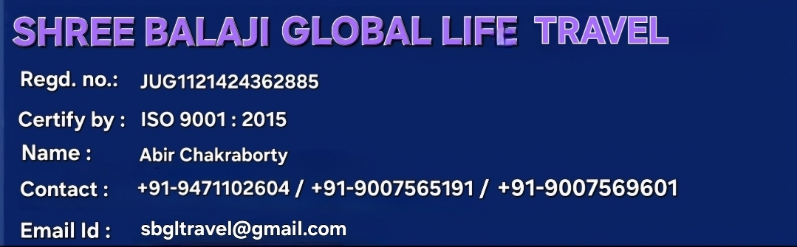



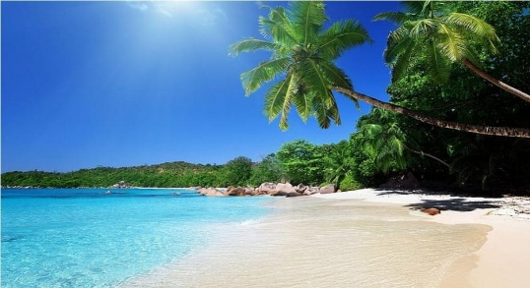
(GROUPREQUEST@GOINDIGO.IN)
BHUTAN INTERNATIONAL TOUR With COCHBIHAR
8 NIGHTS & 9 DAYS- Day Wise Itinerary:

TOUR AT A GLANCE
DAY 1:TATA TO HASHIMRA STATION
DAY 2: PICK UP FROM HASHIMRA STATION TO PHUENTSHOLING
DAY 3: PHUENTSHOLING TO THIMPHU
DAY 4:THIMPHU TO PUNAKHA COMPLETE SIGHTSEING (NIGHT ………............STAY AT PARO )
DAY5: PARO LOCAL SIGHTSEEING
DAY 6:PARO HALF DAY TO PHUENHTSHOLING/ JAIGAON TO ………….……..JALDAPARA
DAY 7:JALDAPARA TO COCHBIHAR LOCAL TO HASIMARA
DAY 8:HASHIMRA STATION TO TATANAGAR
DAY 9: ARRIVAL AT TATANAGAR

Stay
1 Night - PHUENTSHOLING
2 Night -THIMPHU
2 Night -PARO TOWN
1 Night - JALDAPADA

(1st Day) Sightseeing*Welcome to Bhutan* (Arrival and Transfer to PHUENTSHOLING)
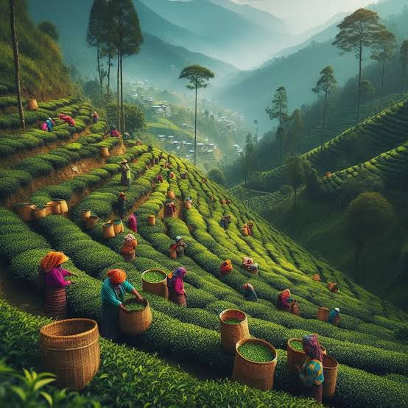

- Meet &Greet on arrival by our representative at HasimaraRailway Station
- VisitTea Garden Estates
- Lunch atLocal Restaurant
- Hotel Drop
- Dinner at Hotel and then Rest at Hotel

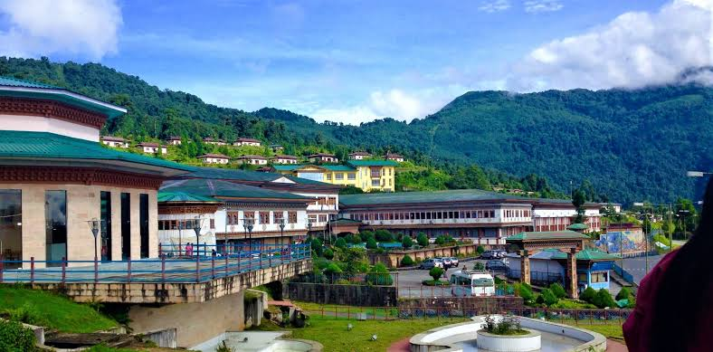
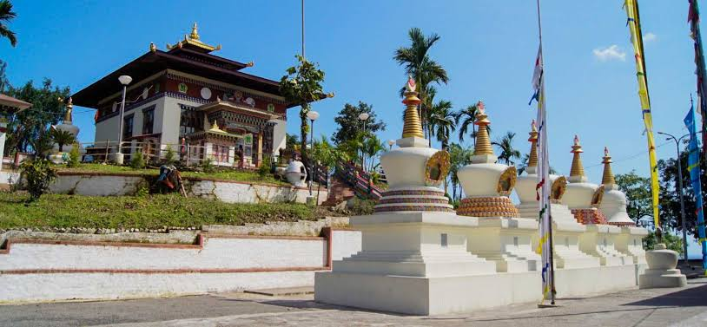
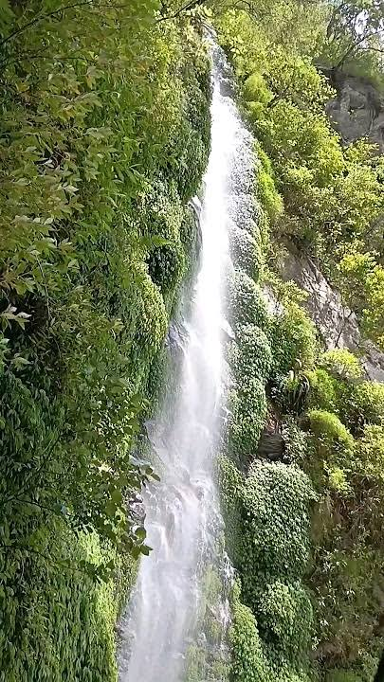
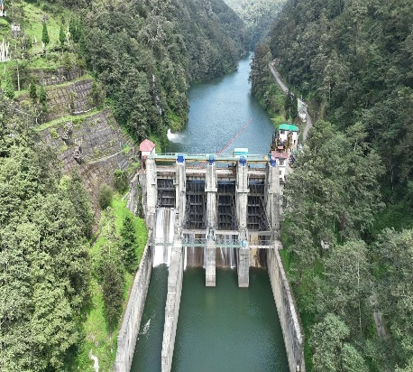
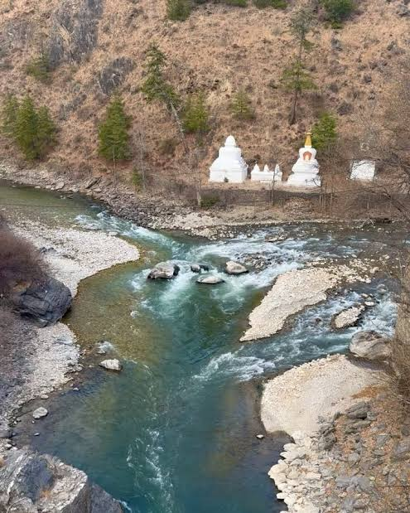
(2nd Day) Sightseeing (Phuentsholing to Thimphu)

- After Breakfast Hotel Pickup
- Transfer to Thimphu after Permit formalities
- On the way visit Kharbandigumba, Gedu, Chukha Dam,Wankha waterfalls,
- Halt at Chojum Bride to take photographs of confluence of two rivers of Bhutan, Thimphu Chu and Paro Chu.
- Hotel Drop
- Enjoy with Dinner then Rest at Hotel

(3rd Day) Sightseeing (ThimphuLocal Sightseeing)
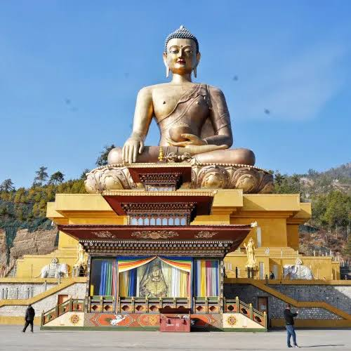
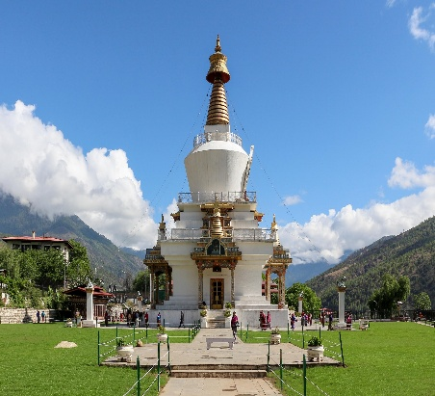
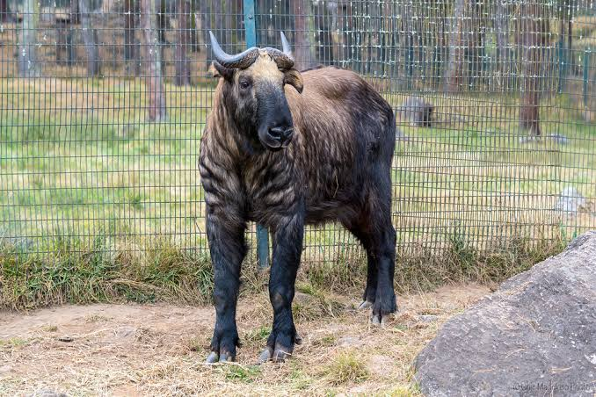
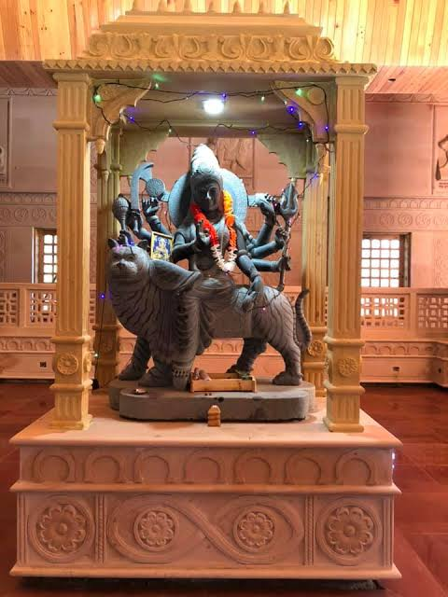
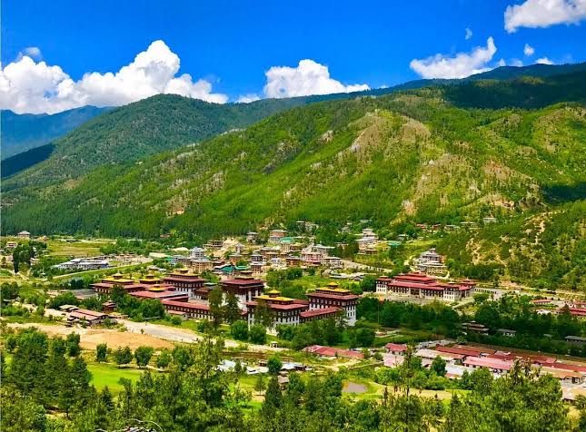

- Hotel Pick Up.
- Breakfast at Hotel
- ThimphuLocalSightseeing
- The National Memorial Chorten, Buddha Dordenma Statue, The motitang Takin Preserve,Bhutan Textile Museum, The Clock Tower
- Lunch at Local Restaurant
- Simply Bhutan, Durga Temple.
- Hotel DropinThimphu
- Enjoy with Dinner then Rest at Hotel

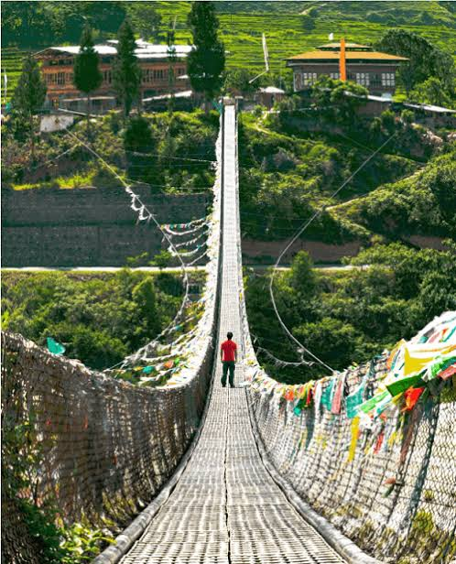
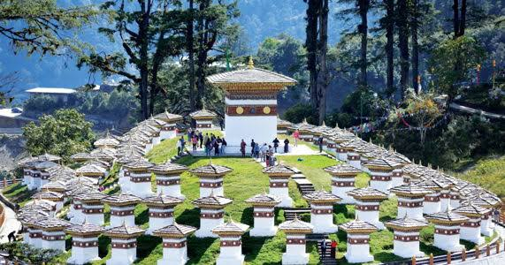
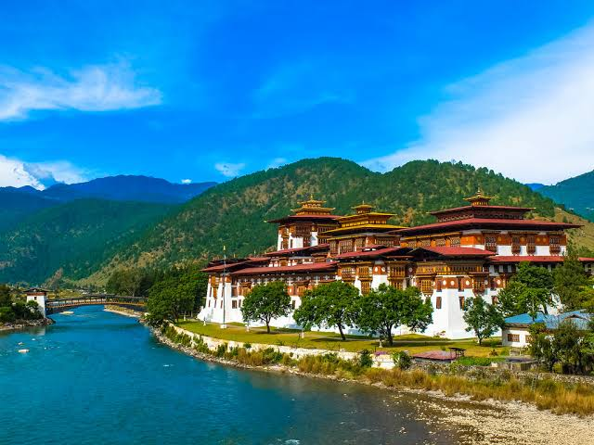
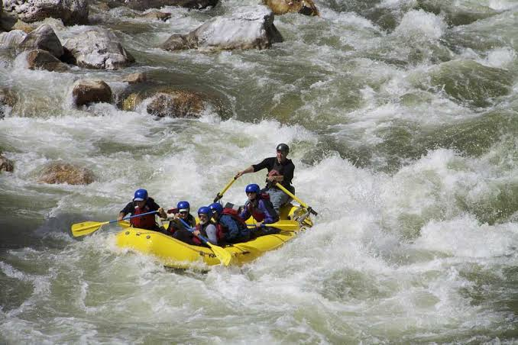
(4th Day) Sightseeing (Thimphu to Punakha)

- Hotel Pickup
- Early morning breakfast
- Visit Dochula Pass View Point, (Fertility Temple), Punakha Dzong (Most Beautiful Dzong), Suspension Bridge.
- Activity - River Rafting at Mho / Pho Chuu river sightseeing. (Optional)
- Lunch at Local Restaurant
- Drive towards Paro.
- Hotel Drop
- Enjoy with Dinner Then Rest atHotel.

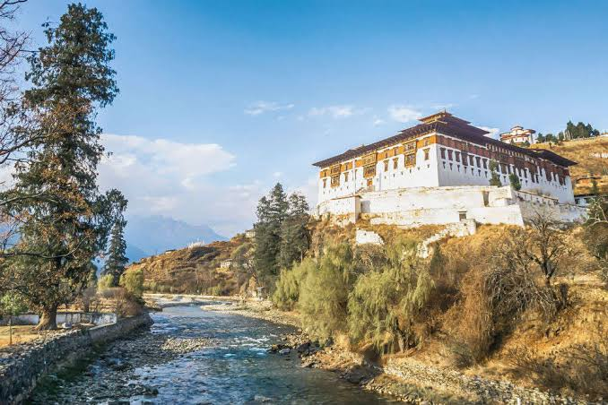
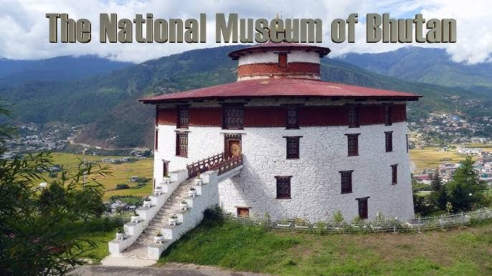
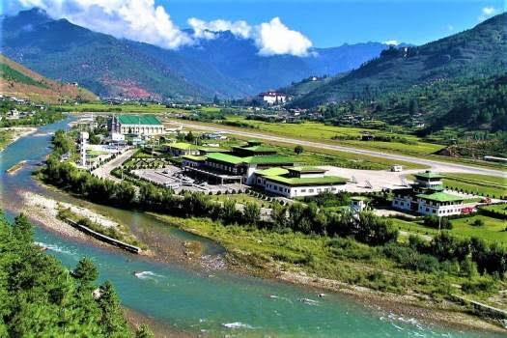
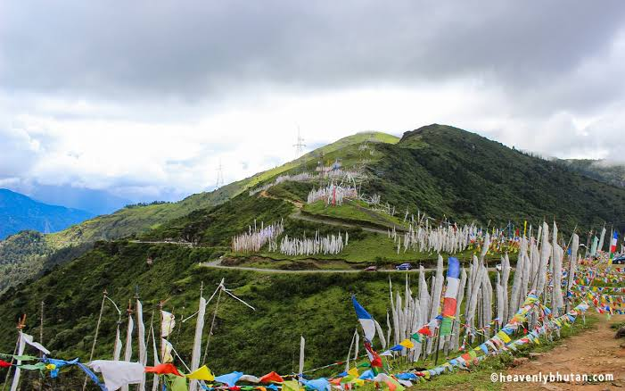
(5th Day) SightseeingPARO local/Chelela pass

- Hotel Pickup
- Early morning breakfast
- VisitParo Airport View Point, Buddhist Temple
- Visit National Museum of Bhutan, Ta Dzong , RinpungDzong.
- Lunch at Local Restaurant
- Hotel Drop
- Enjoywith Dinner then Rest at Hotel.

(6th Day) Sightseeing (Paro To Phuentsholing to Jaldapara drop)

- After Breakfsat check out from hotel , do the necessary shoppingFrom local market and drive to Phuentsholing , Drop till Jaldapara . Overnight Hotel in Jaldapra.
- Hotel Pickup & Early morning breakfast
- Check out from Hotel
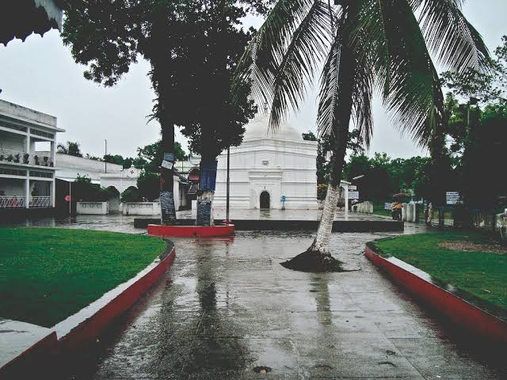
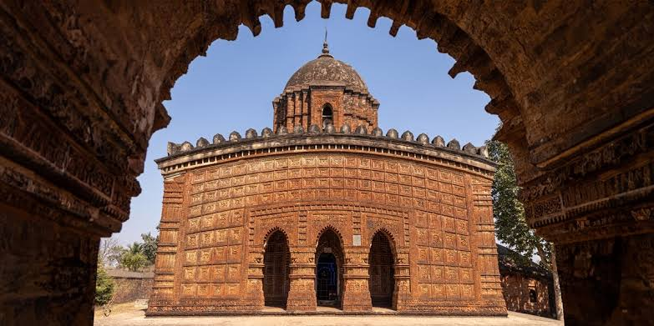
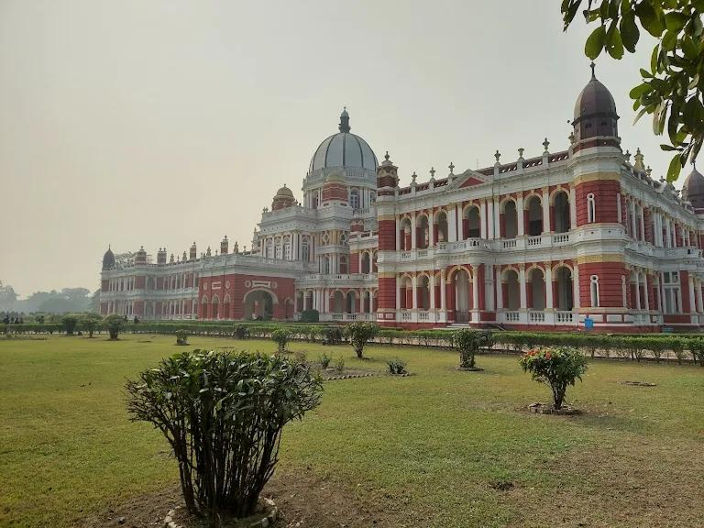
(7th Day) Sightseeing (JaldaparaCochbihar local to Hasimara drop )

- After Breakfast early morning Drive to cochbihar, we will reach in 2hour
- Visit Cooch Behar Rajbari (Palace), Madan Mohan Temple
Baneswar Temple

(8th Day)HASHIMRA STATION TO TATANAGAR

- TOUR ENDS HERE WTTH HAPPY MEMORIES….

(9th Day) HASHIMRA STATION TO TATANAGAR

- Arival at Tatanagar in afternoon

Package Included:
- All permit fees & hotel taxes (as per itinerary).
- Driver Allowances
- SDF Charges –(SUSTAINABLE DEVELOPMENT FEES ) for ADULTS X Per Nights (Rs. 1200/-) Included
- 01 Professional English-Hindi Speaking Guide
- Mineral Water assistance during day tour BHUTAN PART
- 3 Tier AC Train fare
- Train Food
- Entrance Fees (Monument Entry Fees/Safari Charges/Sightseeing Entry)
- Meals as per itinerary (B+L+D)
- 8 NIGHTS &9 DAYS Stay Including theDeluxe / Semi deluxe Room
- Comfortable Vehicle for Sightseeing
- Tata to Bhutan UP / DOWN Charges Included
- Package cost*38,000* /Rs.

Entry Fee Charges Included:(Sightseeing)

Simply Bhutan Rs. 1000/-
Punakha Dzong (Most Beautiful Dzong) Rs. 500/-
The National Memorial ChortenRs. 500/-
National Museum of Bhutan Rs. 300/-
Buddha Dordenma Statue Rs. 300/-
The motitang Takin Preserve Rs. 300/-
Bhutan Textile Museum Rs.250/-
KharbandigumbaRs. 50/-
The Clock Tower
Gedu
Chukha Dam
Wankha waterfalls
Durga Temple
Dochula Pass View Point (Fertility Temple)
Suspension Bridge
Chelela Pass
Paro Airport View Point RinpungDzong
Cooch Behar Rajbari (Palace)
Madan Mohan Temple
Baneswar Temple

Package Excluded:
- Personal Expenses such as Laundry, telephone calls, tips & gratuity, mineral water, rafting, paragliding, Porterage.
- Additional sightseeing or extra usage of vehicle, other than mentioned in the itinerary.
- Any cost arising due to natural calamities like, landslides, road blockage, political disturbances (strikes), etc (to be borne by the client, which is directly payable on the spot).
Cancellation Policy :
- Minimum Cancellation is Rs. 4000/- per Head.
- 25% Between 30-20 Days Before Tour Departure
- 50% Between 20-10 Days Before Tour Departure
- 75% Between 10-05 Days Before Tour Departure
- 100% on the Same Day & No show.

IMPORTANT INFORMATION:
- As per Tourism Council Of Bhutan All Indian tourist above 12 years will have to pay 1200 per person per night as Sustainable Development Fee (SDF) and Children 5 to 12 years will have to pay 600 per person per night .Child below 5 years do not have to pay any charges.
- Documents required for Bhutan Immigration is ONLY Voter id/Passport (minimum validity 6 months for passport)
- Children below 18 years can carry birth Certificate in English
- All Tourist will have to stay in 3* and above hotels only
- Tourist are not allowed to stay below 3* hotels
- SDF charges : Below 5 years is free – 5 to 12 years 600 per night above 12 years 1200 per night( per person per night)
- As per new Tourism rules Guide is Mandatory in Bhutan
- Travel Insurance is Mandatory in Bhutan
- Hotels are very strict with the child policy. Please carry the age proof so that it can be produced if asked by hotel.
- A valid photo ID proof for all guests staying at the hotel is mandatory.
- For Extra adult in the room we will provide an extra bed (wherever possible), but most of the hotels only provide extra mattress or roll out bed. Most of the hotels have no provision of an extra bed.
- The above mentioned hotels will be confirmed as per the room availability. Otherwise similar category hotel will be provided. All the rooms are base category
- Above rates are for Indian Nationals

